Problem 2

Query 1 (AQ1)

SELECT
Location_Name, Time_Year, Time_Month,
SUM ( QUANTITY_ORDERED * Unit_Price ) AS SumJobAmt,
SUM ( SUM ( QUANTITY_ORDERED * Unit_Price ) )
OVER ( PARTITION BY Location_Name, Time_Year
ORDER BY Time_Month
ROWS UNBOUNDED PRECEDING ) AS CumSumAmt
FROM W_JOB_F, W_Location_D, W_TIME_D
WHERE W_Location_D.Location_ID = W_Job_F.Location_Id
AND W_JOB_F.CONTRACT_DATE = W_TIME_D.Time_ID
GROUP BY Location_Name, Time_Year, Time_Month;

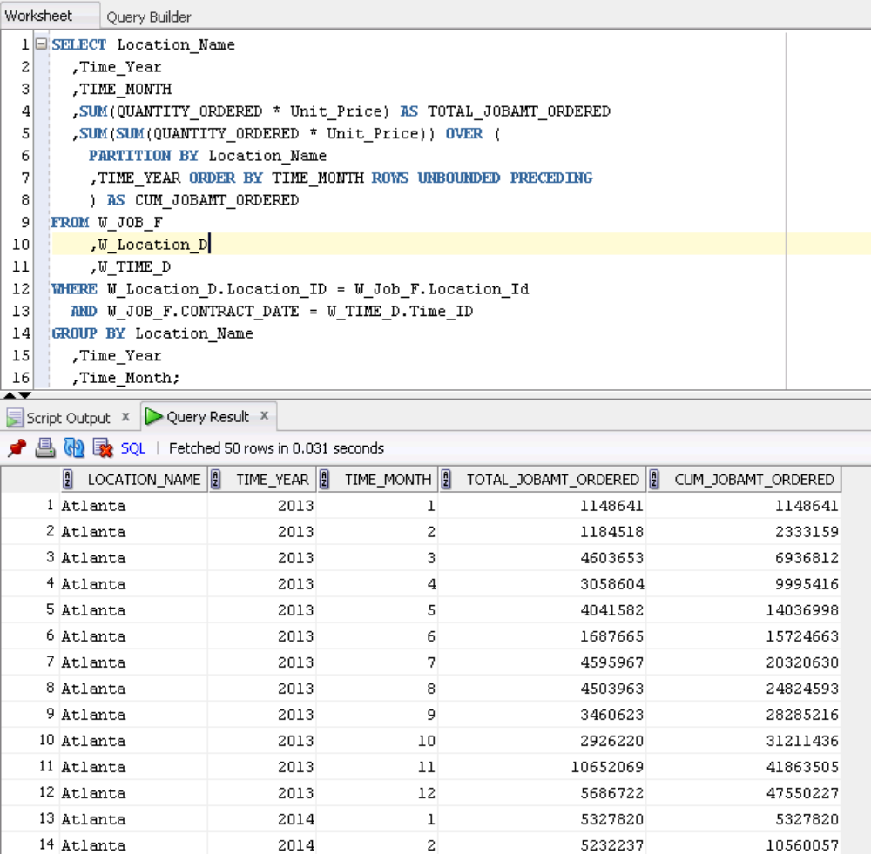

Query 2 (AQ2)

SELECT Location_Name, Time_Year, Time_Month,
AVG( QUANTITY_ORDERED * Unit_Price ) AS AvgJobAmount ,
AVG( AVG( QUANTITY_ORDERED * Unit_Price ) )
OVER ( PARTITION BY Location_Name
ORDER BY Time_Year, Time_Month
ROWS BETWEEN 11 PRECEDING AND CURRENT ROW ) AS MovAvgAmtOrdered
FROM W_JOB_F, W_Location_D, W_TIME_D
WHERE W_Location_D.Location_ID = W_Job_F.Location_Id
AND W_JOB_F.CONTRACT_DATE = W_TIME_D.Time_ID
GROUP BY Location_Name, Time_Year, Time_Month;

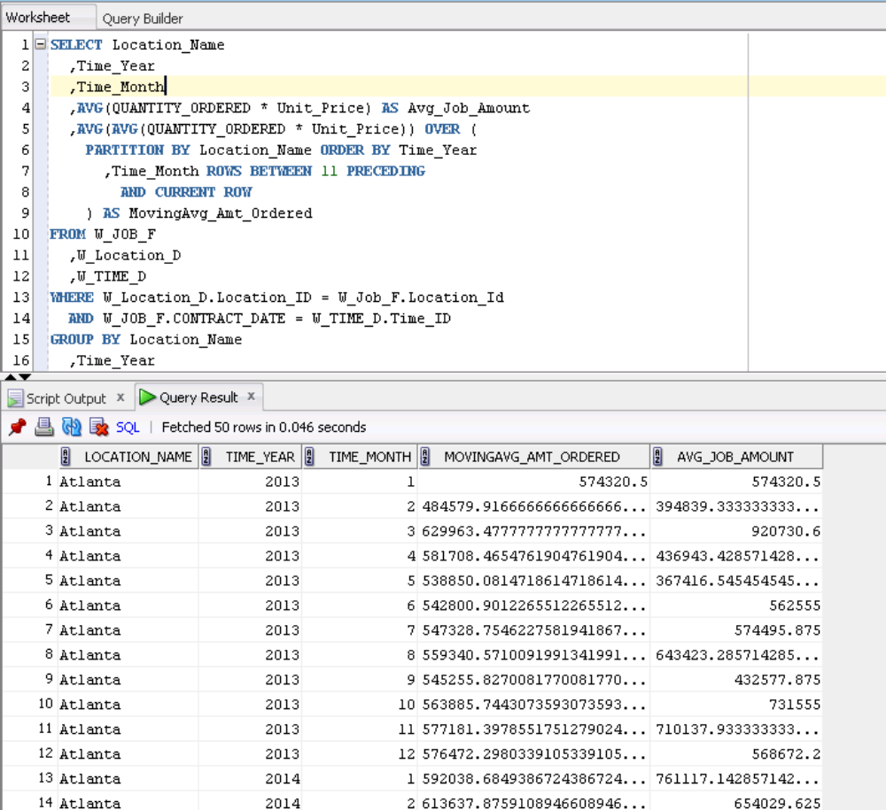

Query 3 (AQ3)

SELECT X1.Location_Name, X1.Time_Year,
SUM(SumInvoiceAmt - TotalCosts) AS SumLocProfit,
RANK() OVER ( PARTITION BY X1.Time_Year
ORDER BY ( SUM(SumInvoiceAmt - TotalCosts) ) DESC ) AS RankProfitSum
FROM LocCostSummary X1, LocRevenueSummary X2
WHERE X1.Job_Id = X2.Job_Id
GROUP BY X1.Location_Name, X1.Time_Year;

SELECT X1.Location_Name, X1.Time_Year,
SUM(SumInvoiceAmt - TotalCosts) AS SumLocProfit,
RANK() OVER ( PARTITION BY X1.Time_Year
ORDER BY ( SUM(SumInvoiceAmt - TotalCosts) ) DESC ) AS RankProfitSum
FROM
(
SELECT W_Sub_Job_F.Job_Id, W_Location_D.LOCATION_ID,
W_LOCATION_D.LOCATION_NAME,
W_TIME_D.TIME_YEAR, W_TIME_D.TIME_MONTH,
SUM (Invoice_Quantity) AS SumInvoiceQty,
SUM (Invoice_Amount) AS SumInvoiceAmt
FROM W_Job_Shipment_F, W_Sub_Job_F, W_Location_D, W_Time_D,
W_InvoiceLine_F, W_Job_F
WHERE W_Sub_Job_F.Sub_Job_Id = W_Job_Shipment_F.Sub_Job_Id
AND W_Job_Shipment_F.Invoice_Id = W_InvoiceLine_F.Invoice_Id
AND W_Time_D.Time_Id = Contract_Date
AND W_Location_D.Location_Id = W_InvoiceLine_F.Location_Id
AND W_Job_F.Job_Id = W_Sub_Job_F.Job_Id
GROUP BY W_Sub_Job_F.Job_Id, W_Location_D.LOCATION_ID,
W_LOCATION_D.LOCATION_NAME, W_TIME_D.TIME_YEAR,
W_TIME_D.TIME_MONTH
) X1,
(
SELECT W_Sub_Job_F.Job_Id, W_Location_D.LOCATION_ID,
W_LOCATION_D.LOCATION_NAME,
W_TIME_D.TIME_YEAR, W_TIME_D.TIME_MONTH,
SUM(Cost_Labor) AS SumLaborCosts,
SUM(Cost_Material) AS SumMaterialCosts,
SUM(Cost_Overhead) AS SumOvrhdCosts,
SUM(Machine_Hours * Rate_Per_Hour) AS SumMachineCosts,
SUM(Quantity_Produced) AS SumQtyProduced,
SUM(Cost_Labor + Cost_Material + Cost_Overhead +
(Machine_Hours * Rate_Per_Hour)) AS TotalCosts
FROM W_Job_F, W_Sub_Job_F, W_Location_D, W_Time_D, W_Machine_Type_D
WHERE W_Job_F.Location_Id = W_Location_D.Location_Id
AND W_Sub_Job_F.Machine_Type_Id = W_Machine_Type_D.Machine_Type_Id
AND W_Time_D.Time_Id = Contract_Date
AND W_Job_F.Job_Id = W_Sub_Job_F.Job_Id
GROUP BY W_Sub_Job_F.Job_Id, W_Location_D.LOCATION_ID,
W_LOCATION_D.LOCATION_NAME, W_TIME_D.TIME_YEAR,
W_TIME_D.TIME_MONTH
) X2
WHERE X1.Job_Id = X2.Job_Id
GROUP BY X1.Location_Name, X1.Time_Year;

Snapshot:
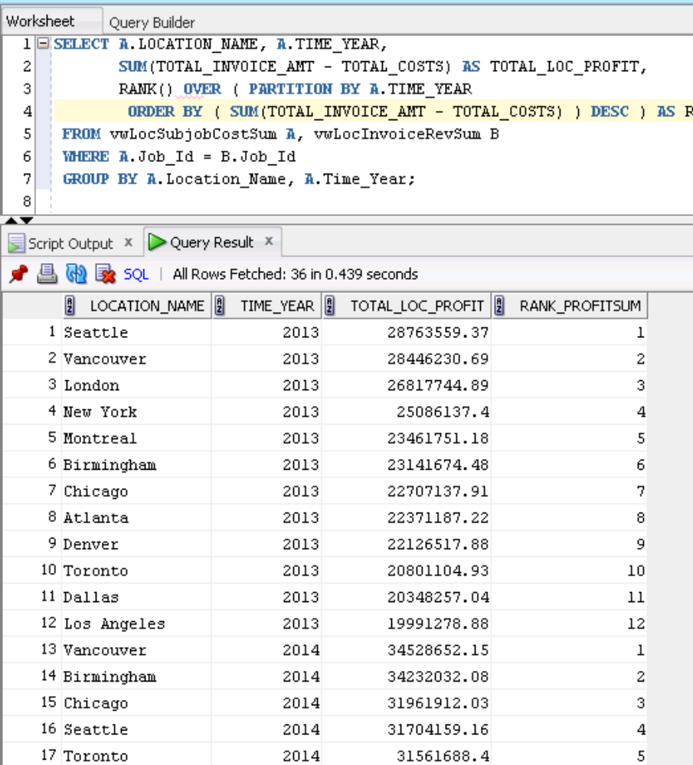

Query 4 (AQ4)

SELECT X1.Location_Name, X1.Time_Year,
SUM (SumInvoiceAmt - TotalCosts) / SUM(SumInvoiceAmt) AS ProfitMargin,
RANK() OVER ( PARTITION BY X1.Time_Year
ORDER BY ( SUM (SumInvoiceAmt - TotalCosts) / SUM(SumInvoiceAmt) ) DESC ) AS RankProfitMargin
FROM LocCostSummary X1, LocRevenueSummary X2
WHERE X1.Job_Id = X2.Job_Id
GROUP BY X1.Location_Name, X1.Time_Year;

-- Base queries for location revenue and location cost summaries

SELECT X1.Location_Name, X1.Time_Year,
SUM (SumInvoiceAmt - TotalCosts) / SUM(SumInvoiceAmt) AS ProfitMargin,
RANK() OVER ( PARTITION BY X1.Time_Year
ORDER BY ( SUM (SumInvoiceAmt - TotalCosts) / SUM(SumInvoiceAmt) )
DESC ) AS RankProfitMargin
FROM
(
SELECT W_Sub_Job_F.Job_Id, W_Location_D.LOCATION_ID,
W_LOCATION_D.LOCATION_NAME, W_TIME_D.TIME_YEAR,
W_TIME_D.TIME_MONTH, SUM (Invoice_Quantity) AS SumInvoiceQty,
SUM (Invoice_Amount) AS SumInvoiceAmt
FROM W_Job_Shipment_F, W_Sub_Job_F, W_Location_D, W_Time_D,
_InvoiceLine_F, W_Job_F
WHERE W_Sub_Job_F.Sub_Job_Id = W_Job_Shipment_F.Sub_Job_Id
AND W_Job_Shipment_F.Invoice_Id = W_InvoiceLine_F.Invoice_Id
AND W_Time_D.Time_Id = Contract_Date
AND W_Location_D.Location_Id = W_InvoiceLine_F.Location_Id
AND W_Job_F.Job_Id = W_Sub_Job_F.Job_Id
GROUP BY W_Sub_Job_F.Job_Id, W_Location_D.LOCATION_ID,
W_LOCATION_D.LOCATION_NAME, W_TIME_D.TIME_YEAR,
W_TIME_D.TIME_MONTH
) X1,
(
SELECT W_Sub_Job_F.Job_Id, W_Location_D.LOCATION_ID,
W_LOCATION_D.LOCATION_NAME,
W_TIME_D.TIME_YEAR, W_TIME_D.TIME_MONTH,
SUM(Cost_Labor) AS SumLaborCosts,
SUM(Cost_Material) AS SumMaterialCosts,
SUM(Cost_Overhead) AS SumOvrhdCosts,
SUM(Machine_Hours * Rate_Per_Hour) AS SumMachineCosts,
SUM(Quantity_Produced) AS SumQtyProduced,
SUM(Cost_Labor + Cost_Material + Cost_Overhead +
(Machine_Hours * Rate_Per_Hour)) AS TotalCosts
FROM W_Job_F, W_Sub_Job_F, W_Location_D, W_Time_D, W_Machine_Type_D
WHERE W_Job_F.Location_Id = W_Location_D.Location_Id
AND W_Sub_Job_F.Machine_Type_Id = W_Machine_Type_D.Machine_Type_Id
AND W_Time_D.Time_Id = Contract_Date
AND W_Job_F.Job_Id = W_Sub_Job_F.Job_Id
GROUP BY W_Sub_Job_F.Job_Id, W_Location_D.LOCATION_ID,
W_LOCATION_D.LOCATION_NAME, W_TIME_D.TIME_YEAR,
W_TIME_D.TIME_MONTH
) X2
WHERE X1.Job_Id = X2.Job_Id
GROUP BY X1.Location_Name, X1.Time_Year;

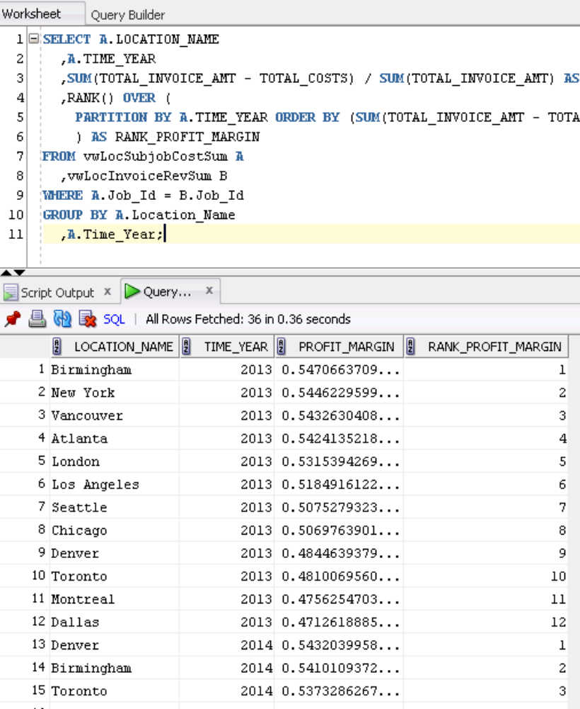

Query 5 (AQ5)

SELECT X1.Job_Id, X1.Location_Name, X1.Time_Year, X1.Time_Year,
(SumInvoiceAmt - TotalCosts) / SumInvoiceAmt AS ProfitMargin,
PERCENT_RANK() OVER (
ORDER BY ( (SumInvoiceAmt - TotalCosts) / SumInvoiceAmt ) )
AS PercentRankProfitMargin
FROM LocCostSummary X1, LocRevenueSummary X2
WHERE X1.Job_Id = X2.Job_Id;

-- Using base queries for location revenue and location cost summaries

SELECT X1.Job_Id, X1.Location_Name, X1.Time_Year, X1.Time_Month,
(SumInvoiceAmt - TotalCosts) / SumInvoiceAmt AS ProfitMargin,
PERCENT_RANK() OVER (
ORDER BY ( (SumInvoiceAmt - TotalCosts) / SumInvoiceAmt ) )
AS PercentRankProfitMargin
FROM
(
SELECT W_Sub_Job_F.Job_Id, W_Location_D.LOCATION_ID,
W_LOCATION_D.LOCATION_NAME,
W_TIME_D.TIME_YEAR, W_TIME_D.TIME_MONTH,
SUM (Invoice_Quantity) AS SumInvoiceQty,
SUM (Invoice_Amount) AS SumInvoiceAmt
FROM W_Job_Shipment_F, W_Sub_Job_F, W_Location_D, W_Time_D,
W_InvoiceLine_F, W_Job_F
WHERE W_Sub_Job_F.Sub_Job_Id = W_Job_Shipment_F.Sub_Job_Id
AND W_Job_Shipment_F.Invoice_Id = W_InvoiceLine_F.Invoice_Id
AND W_Time_D.Time_Id = Contract_Date
AND W_Location_D.Location_Id = W_InvoiceLine_F.Location_Id
AND W_Job_F.Job_Id = W_Sub_Job_F.Job_Id
GROUP BY W_Sub_Job_F.Job_Id, W_Location_D.LOCATION_ID,
W_LOCATION_D.LOCATION_NAME, W_TIME_D.TIME_YEAR, W_TIME_D.TIME_MONTH
) X1,
(
SELECT W_Sub_Job_F.Job_Id, W_Location_D.LOCATION_ID,
W_LOCATION_D.LOCATION_NAME,
W_TIME_D.TIME_YEAR, W_TIME_D.TIME_MONTH,
SUM(Cost_Labor) AS SumLaborCosts,
SUM(Cost_Material) AS SumMaterialCosts,
SUM(Cost_Overhead) AS SumOvrhdCosts,
SUM(Machine_Hours * Rate_Per_Hour) AS SumMachineCosts,
SUM(Quantity_Produced) AS SumQtyProduced,
SUM(Cost_Labor + Cost_Material + Cost_Overhead +
(Machine_Hours * Rate_Per_Hour)) AS TotalCosts
FROM W_Job_F, W_Sub_Job_F, W_Location_D, W_Time_D, W_Machine_Type_D
WHERE W_Job_F.Location_Id = W_Location_D.Location_Id
AND W_Sub_Job_F.Machine_Type_Id = W_Machine_Type_D.Machine_Type_Id
AND W_Time_D.Time_Id = Contract_Date
AND W_Job_F.Job_Id = W_Sub_Job_F.Job_Id
GROUP BY W_Sub_Job_F.Job_Id, W_Location_D.LOCATION_ID,
W_LOCATION_D.LOCATION_NAME, W_TIME_D.TIME_YEAR, W_TIME_D.TIME_MONTH
) X2
WHERE X1.Job_Id = X2.Job_Id;

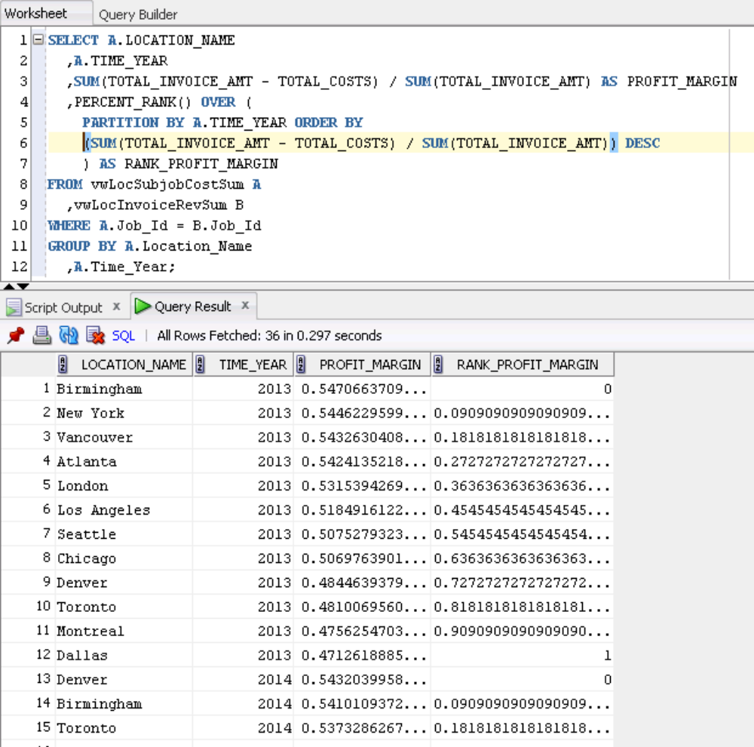

Query 6 (AQ6)

SELECT Job_Id, Location_Name, Time_Year, Time_Month,
ProfitMargin, PercentRankProfitMargin
FROM (
SELECT X1.Job_Id, X1.Location_Name, X1.Time_Year, X1.Time_Month,
(SumInvoiceAmt - TotalCosts) / SumInvoiceAmt AS ProfitMargin,
PERCENT_RANK() OVER (
ORDER BY ( (SumInvoiceAmt - TotalCosts) / SumInvoiceAmt ) )
AS PercentRankProfitMargin
FROM LocCostSummary X1, LocRevenueSummary X2
WHERE X1.Job_Id = X2.Job_Id )
WHERE PercentRankProfitMargin > 0.95;
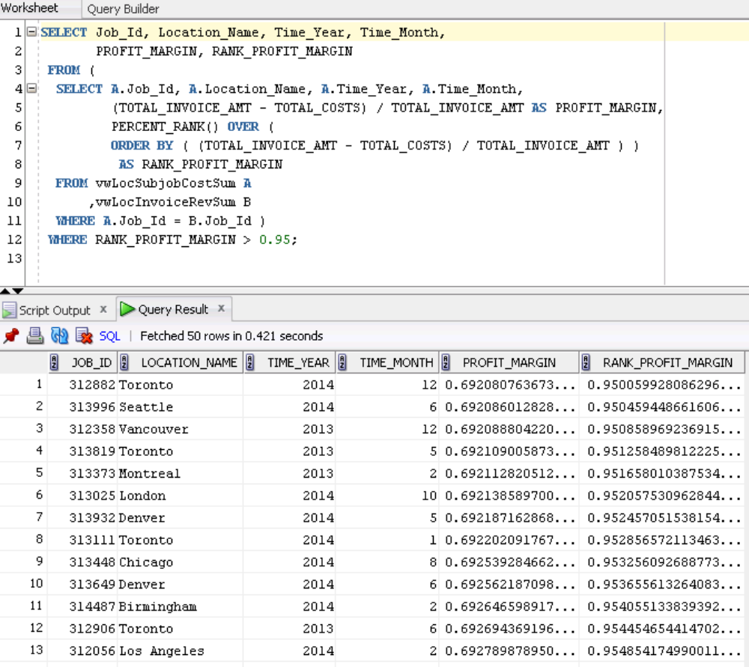

Query 7 (AQ7)

SELECT Sales_Class_Desc, Time_Year,
SUM ( quantity_shipped - invoice_quantity ) as ReturnSum ,
RANK() over ( PARTITION BY Time_Year
ORDER BY SUM ( quantity_shipped - invoice_quantity ) DESC )
AS RankReturnSum
FROM W_INVOICELINE_F INNER JOIN W_TIME_D
ON W_INVOICELINE_F.INVOICE_SENT_DATE = W_TIME_D.TIME_ID
INNER JOIN W_Sales_Class_D
ON W_INVOICELINE_F.Sales_Class_Id = W_Sales_Class_D.Sales_Class_Id
WHERE quantity_shipped > invoice_quantity
GROUP BY Sales_Class_Desc, Time_Year;
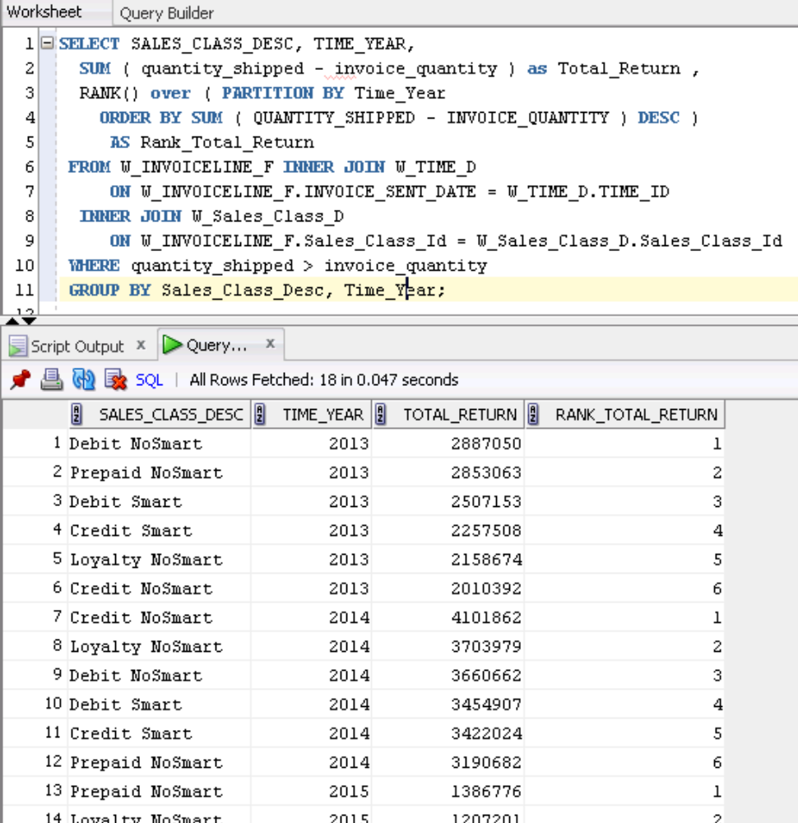

Query 8 (AQ8)
SELECT Time_Year, Sales_Class_Desc,
SUM ( quantity_shipped - invoice_quantity ) as SumReturnQty,
Ratio_To_Report(SUM ( quantity_shipped - invoice_quantity ))
OVER ( PARTITION BY Time_Year ) AS RatioReturnSum
FROM W_INVOICELINE_F INNER JOIN W_TIME_D
ON W_INVOICELINE_F.INVOICE_SENT_DATE = W_TIME_D.TIME_ID
INNER JOIN W_Sales_Class_D
ON W_INVOICELINE_F.Sales_Class_Id = W_Sales_Class_D.Sales_Class_Id
WHERE quantity_shipped > invoice_quantity
GROUP BY Sales_Class_Desc, Time_Year
ORDER BY Time_Year, SUM( quantity_shipped - invoice_quantity );

Query 9 (AQ9)

SELECT Location_Name, W_Time_D.Time_Year,
SUM(BusDaysDiff) as SumDelayDays,
RANK() OVER ( PARTITION BY W_Time_D.Time_Year
ORDER BY SUM(BusDaysDiff) DESC) AS RankSumDelayDays,
DENSE_RANK() OVER ( PARTITION BY W_Time_D.Time_Year
ORDER BY SUM(BusDaysDiff) DESC) AS RankSumDelayDays
FROM FirstShipmentDelays, W_Time_D
WHERE W_Time_D.Time_Id = FirstShipmentDelays.Date_Ship_By
GROUP BY Location_Name, W_Time_D.Time_Year;
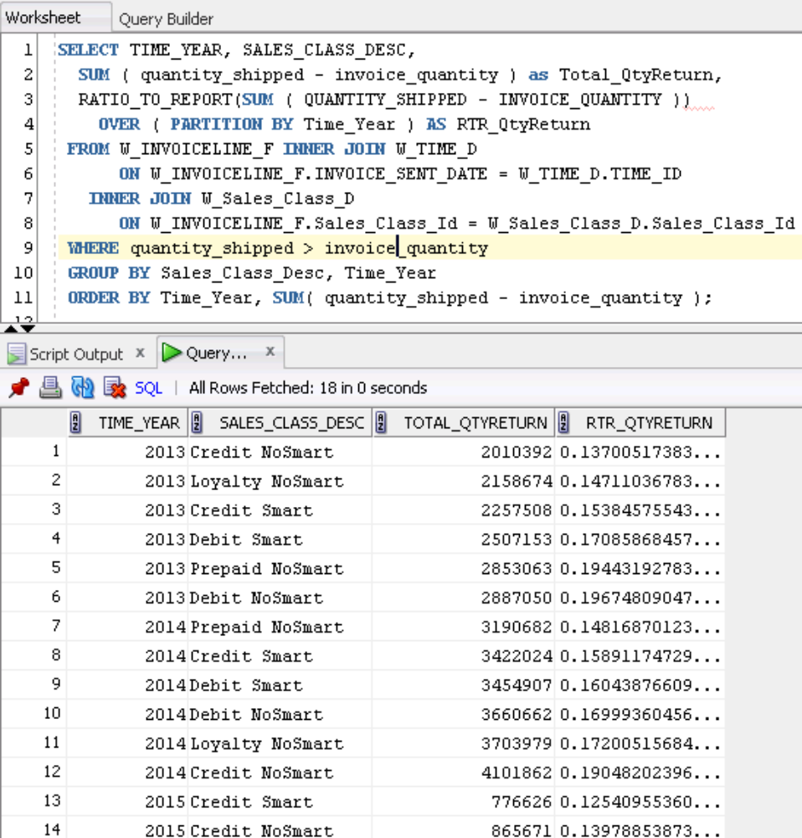

Query 9 (AQ9)

SELECT Location_Name, W_Time_D.Time_Year,
SUM(BusDaysDiff) as SumDelayDays,
RANK() OVER ( PARTITION BY W_Time_D.Time_Year
ORDER BY SUM(BusDaysDiff) DESC) AS RankSumDelayDays,
DENSE_RANK() OVER ( PARTITION BY W_Time_D.Time_Year
ORDER BY SUM(BusDaysDiff) DESC) AS RankSumDelayDays
FROM FirstShipmentDelays, W_Time_D
WHERE W_Time_D.Time_Id = FirstShipmentDelays.Date_Ship_By
GROUP BY Location_Name, W_Time_D.Time_Year;

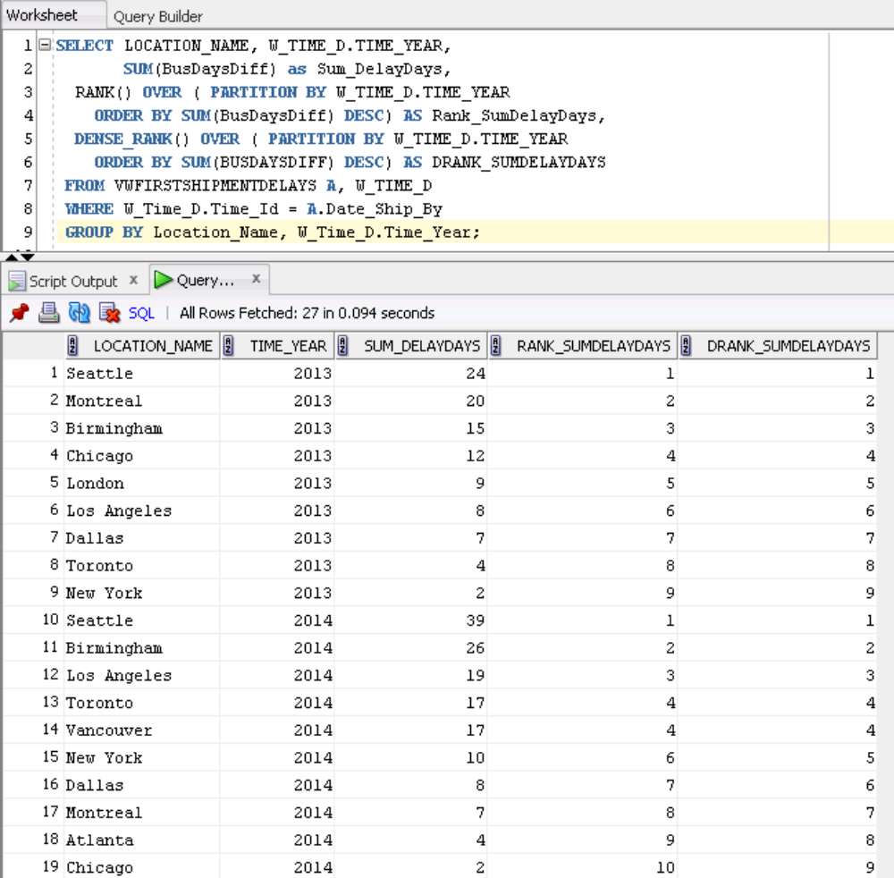

Query 10 (AQ10)

SELECT Location_Name, W_Time_D.Time_Year,
COUNT(*) AS NumJobs,
SUM(BusDaysDiff) as SumDelayDays,
SUM(Quantity_Ordered - SumDelayShipQty) / SUM(Quantity_Ordered)
AS PromisedDelayRate,
RANK() OVER ( PARTITION BY W_Time_D.Time_Year
ORDER BY SUM(Quantity_Ordered - SumDelayShipQty) /
SUM(Quantity_Ordered) DESC) AS RankDelayRate
FROM LastShipmentDelays, W_Time_D
WHERE W_Time_D.Time_Id = LastShipmentDelays.Date_Promised
GROUP BY Location_Name, W_Time_D.Time_Year;

